<https://www.youtube.com/watch?v=_cpqvUoR044>

<https://www.youtube.com/watch?v=z9a_ztJqaII>

sudo apt update

sudo apt upgrade

node -v

v10.24.0

npm -v

v5.8.0

We need to install the “**build-essential**” package. This package is used to build any modules that NPM requires.

sudo apt install build-essential git

This command will install several things to our Raspberry Pi. These packages include Node.js, npm, and Node-RED itself.

bash <(curl -sL <https://raw.githubusercontent.com/node-red/linux-installers/master/deb/update-nodejs-and-nodered>)

bash <(curl -sL <https://raw.githubusercontent.com/node-red/raspbian-deb-package/master/resources/update-nodejs-and-nodered>)

|  |  |
| --- | --- |
|  | 1. While Node-RED is available through the Raspbian package repository, the script (linux) is the officially recommended install method as it also installs npm. First, the script will remove any pre-existing Node-RED and Node.js installations to avoid conflicts with previous versions. 2. Next, it will install Node.JS LTS using the [NodeSource package repository](https://github.com/nodesource/distributions/blob/master/README.md" \t "_blank). |

1. npm will be used to install the latest version of Node-RED to your Raspberry Pi.
2. In this step, the script will install any Raspberry Pi specific modules to the OS.
3. Finally, a service for Node-RED will be generated by the script.

Si usa el package Linux no necesitara hacer lo siguiente porque ya install npm

sudo npm install -g n

sudo n latest

sudo shutdown -r now

Cuando inicia node-red-start le puede aparecer este error

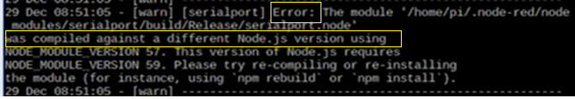

ls -l

cd .node-red

node-red-stop

sudo npm rebuild

node-red-start

El error desaparecio

Puede darle CTL-C el servicio seguira corriendo



Security

- Adding user-name / password account

- Using remote encryption (via https)

Detenga servicio de node-red

sudo systemctl disable nodered.service

node-red-stop

sudo shutdown -r now

cd .node-red

Install Dashboard

npm install node-red-dashboard

**Cambios a setting.js**

cd .node-red

nano settings.js

nano settings.js

uncomment

* var fs = requre("fs")
* ui: { path: "ui" }

Node-RED dashboard can be access via http://192.168.xxx.xxx:1880/ui, however the path /ui is disabled by default.

Press ctrl-w to search ( path: ) or simple scrolling down to search for line with ui: { path: "ui" }and uncomment out the line by deleting the // in front of the line.

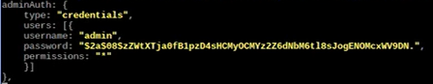

Pressed ctrl-x to save the file.

**Password encryption**

su

raspberry

npm install -g node-red-admin

exit

pwd

cd .node-red

node-red-admin hash-pw

(escribe password y le da lo encriptado)



Le da right-click copy

nano settings.js

Actualiza

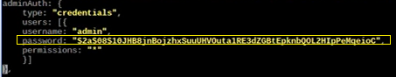

Pressed ctrl-x to save the file.

node-red-start

Vera la IP

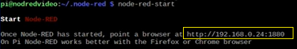

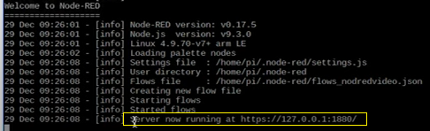

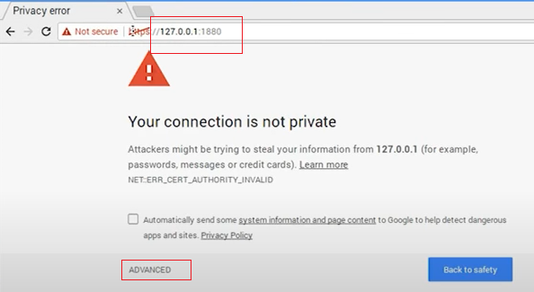

Presione advance para aceptar certificado

Digita **admin** y el password que encripto **Levitico**

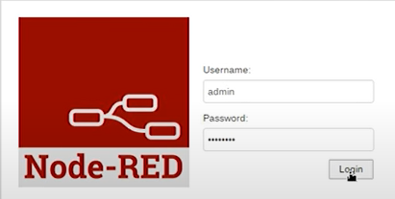

|  |  |
| --- | --- |
| Launch | **node-red-start** |
| Stop | **node-red-stop** |
| Launch as service (as a deamon service) | **sudo systemctl start nodered** |
| Check service status | **Sudo systemctl status nodered** |
| Autostart on boot | **sudo systemctl enable nodered**  **sudo systemctl enable nodered.service** |
| To disable service | **sudo systemctl disable nodered**  **sudo systemctl disable nodered.service** |
| Restart service | **sudo systemctl restart node-red** |

* node-red-start - this starts the Node-RED service and displays its log output. Pressing Ctrl-C or closing the window does *not* stop the service; it keeps running in the background
* node-red-stop - this stops the Node-RED service
* node-red-restart - this stops and restarts the Node-RED service
* node-red-log - this displays the log output of the service

You can also start the Node-RED service on the Raspbian Desktop by selecting the

Menu -> Programming -> Node-RED menu option.

Latest release <https://nodejs.org/>

NO SE NECESITA CERTIFICADO si accede con http en vez de https

Cree certificado gratis, busque codigo de su pais

<https://www.nationsonline.org/oneworld/country_code_list.htm>

Para El Salvador (SV)



cd .node-red

openssl genrsa -out privatekey.pem 1024

openssl req -new -key privatekey.pem -out private-csr.pem

En vez de GB es SV para generar un certificado gratis

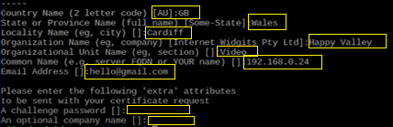

Se creo 3 archivos

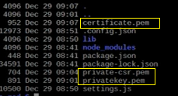

Uncomment in settings.js

